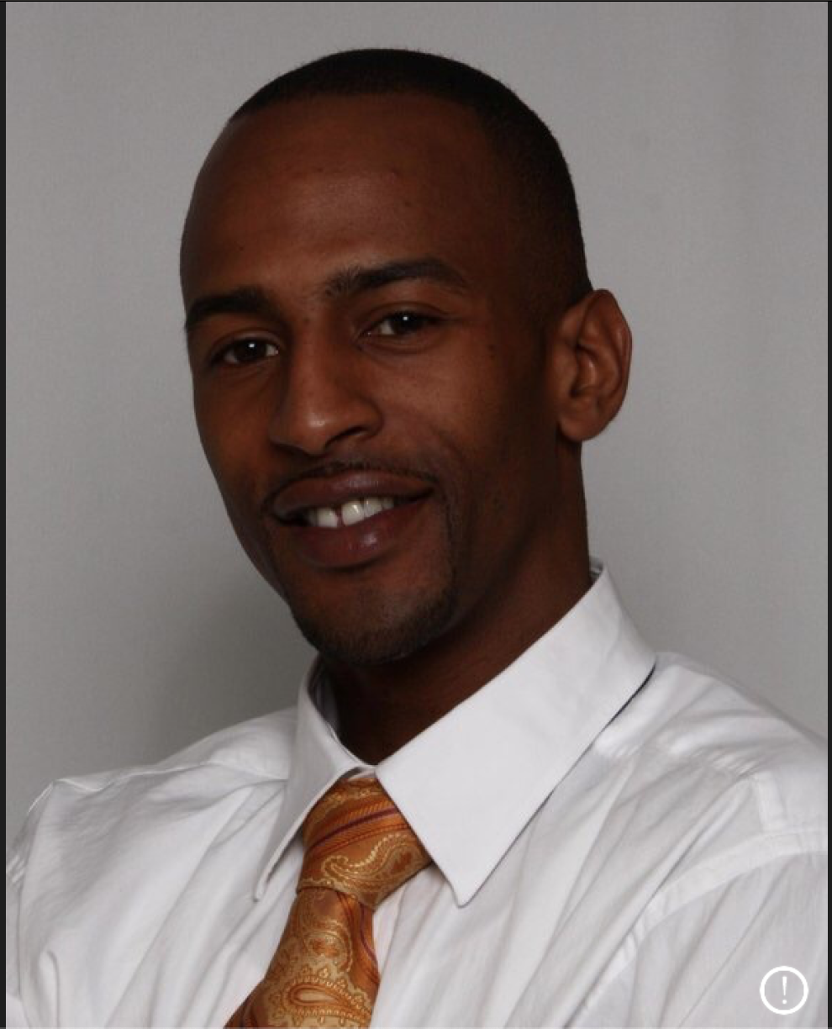 |  | Rollin francois  Salesforce Developer
Profile  - 2 Years of experience in the Salesforce CRM as Administrator and Developer.  - Experience in Apex Development including creating custom objects, fields, custom tabs, triggers, processes and workflows.  - Familiar with Java, C#, Swift, JavaScript, HTML5 and CSS3.  - Experienced with Lightning Web Components, Deploying Code to Org via Git or VSCode.  - Understanding of Lightning Data Service, Org-wide hierarchies, Roles, Profiles, Users, object/field-level security, record-level security and sharing rules.  - Experience working with Standard Objects such as Accounts, Contacts, Opportunities, Cases, Leads, Products, Reports, etc.  Contact  PHONE:  678-758-5055  EMAIL:  francoisellsfast@gmail.com  My trailhead  https://trailblazer.me/id/rfrancois21  LINKEDIN  www.linkedin.com/in/rollin-francois-77278820  CODEACADEMY  /design7949497411  Hobbies  Learning new skills and technologies  Martial Arts (Brazilian Jiujitsu)  Billiards  Real Estate/Investing  Learning on Udemy & similar platforms  Earning Shiny New Trailhead Badges |  | EDUCATION  DeVry University  2009 - 2011  Studied Network Systems Administration and Maintained a minimum of 3.5 GPA throughout coursework and was acknowledged on Dean’s list several times.  WORK EXPERIENCE  Xonic Systems Mobile Developer (iOS)  2017–2019  - Create reusable components that can be applied to iOS applications developed throughout the organization.  - Develop applications using Swift.  - Implement application design based on MVC architecture and RESTful services.  - Create and manage Unit Tests  AGCO Salesforce Application Developer  2016–2018  - Investigate and resolve bug fixes and backlog items.  - Created Custom Objects, Custom Fields, Tabs and maintained field-level security.  - Developed Apex Classes, Triggers, Lightning Web Components, SOQL and Visualforce pages.  - Hands-on experience with Salesforce Communities, SalesforceDX, VSCode, Git, JIRA and Confluence.  - Created training documentation.  Lockheed Martin (Orlando) Software Developer  2014–2016  - Designed, developed and tested Global Defense Web Applications and equipment.  - Investigate and resolve bug fixes.  - Contributed to the design and development of Mobile Application.  - Participated in stakeholder meetings, analyzing and estimating requirements.  SALESFORCE BADGES  - Lightning Web Components Specialist (Superbadge) 12/2020  - Salesforce Platform Basics  - User Authentication  - User Management  - Customize an Org to Support a New Business Unit  - Identity Basics  - Data Modeling  - Accounts & Contacts for Lightning Experience  - Building a Data Model for a Recruiting App  - Leads & Opportunities for Lightning Experience  - Products, Quotes, & Contracts  - Campaign Basics  - Quick Start: Visual Studio Code for Salesforce Development  - Quick Start: Lightning Web Components  - JavaScript Skills for Salesforce Developers  - Get Started with Modern JavaScript Development  - JavaScript Dev 1 Cert Prep: Variables, Collections, Functions, Classes  - JavaScript Dev 1 Cert Prep: Browsers, Async Programming, Server-Side JavaScript  - JavaScript Dev 1 Cert Prep: Debugging, Error Handling, Testing  - Lightning Web Components and Salesforce Data  - Trick or Trailhead VI  - Lightning Web Components Basics  - Lightning Web Components Tests  - Coding for Web Accessibility  - Lightning Web Components Specialist  - Platform Development Basics  - Data Security  - Prepare Your Salesforce Org for Users  - Build a Cat Rescue App That Recognizes Cat Breeds  - Build Your Personal Portfolio on Salesforce  - Apex Basics & Database  - Apex Triggers  - Data Management  - Formulas and Validations

